Commonly performed operations on binary search tree are-

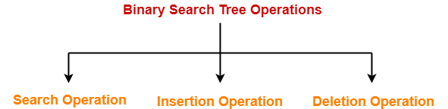

1. Search Operation
2. Insertion Operation
3. Deletion Operation

In this article, we will discuss time complexity of BST Operations.

**Time Complexity-**

* Time complexity of all BST Operations = O(h).
* Here, h = Height of binary search tree

Now, let us discuss the worst case and best case.

**Worst Case-**

In worst case,

* The binary search tree is a skewed binary search tree.
* Height of the binary search tree becomes n.
* So, Time complexity of BST Operations = O(n).

In this case, binary search tree is as good as unordered list with no benefits.

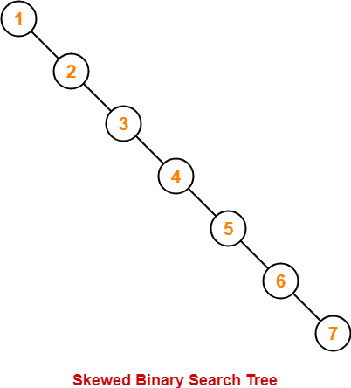

**Best Case-**

In best case,

* The binary search tree is a balanced binary search tree.
* Height of the binary search tree becomes log(n).
* So, Time complexity of BST Operations = O(logn).

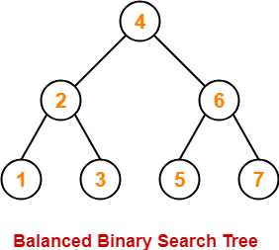

To gain better understanding about Time Complexity of BST Operations,